**TABLE DESIGN**

**ADMIN**

1. **tbl_district**

Description: This table is used to districts

Primary key: district_id

Foreign key: Null

|  |  |  |  |  |
| --- | --- | --- | --- | --- |
| **Sl.No** | **Fieldname** | **Data type** | **Constraints** | **Description** |
| 1 | district_id | Integer | Primary key | Unique id of district |
| 2 | District_name | Varchar(50) | Not null | Name of the District |

1. **tbl_place**

Description: To store the places in each district

Primary key: place_id

Foreign key: district_id

|  |  |  |  |  |
| --- | --- | --- | --- | --- |
| **Sl.No** | **Fieldname** | **Data type** | **Constraints** | **Description** |
| 1 | place_id | Integer | Primary key | Unique id of place |
| 2 | place_name | Varchar(50) | Not null | Name of place |
| 3 | district_id | Varchar(50) | Foreign key | Id of the district |

1. **tbl_playertype**

Description: To store the player type

Primary key: playertype_id

Foreign key: Null

|  |  |  |  |  |
| --- | --- | --- | --- | --- |
| **Sl.No** | **Fieldname** | **Data type** | **Constraints** | **Description** |
| 1 | playertype_id | Integer | Primary key | Unique id of player type |
| 2 | player_type | Varchar(50) | Not null | Name of the type |

1. **tbl_mode**

Description: To store the game mode

Primary key: mode_id

Foreign key: Null

|  |  |  |  |  |
| --- | --- | --- | --- | --- |
| **Sl.No** | **Fieldname** | **Data type** | **Constraints** | **Description** |
| 1 | mode _id | Integer | Primary key | Unique id of game mode |
| 2 | mode _name | Varchar(50) | Not null | Name of the game mode |

1. **tbl_type**

Description: To store the game type

Primary key:type_id

Foreign key: Null

|  |  |  |  |  |
| --- | --- | --- | --- | --- |
| **Sl.No** | **Fieldname** | **Data type** | **Constraints** | **Description** |
| 1 | type_id | Integer | Primary key | Unique id of game type |
| 2 | type_name | Varchar(50) | Not null | Name of the type |

1. **tbl_slot**

Description: To store the slot

Primary key:slot _id

Foreign key: type_id

|  |  |  |  |  |
| --- | --- | --- | --- | --- |
| **Sl.No** | **Fieldname** | **Data type** | **Constraints** | **Description** |
| 1 | slot _id | Integer | Primary key | Unique id of slot |
| 2 | slot _no | Varchar(50) | Not null | Number of the slot |
| 3 | type_id | integer | Foreign key | Unique id of game type |

1. **tbl_subadmin**

Description: To store the details of subadmin

Primary key:subadmin_id

Foreign key: district_id

|  |  |  |  |  |
| --- | --- | --- | --- | --- |
| **Sl.No** | **Fieldname** | **Data type** | **Constraints** | **Description** |
| 1 | subadmin _id | Integer | Primary key | Unique id of subadmin |
| 2 | subadmin _name | Varchar(50) | Not null | Name of the subadmin |
| 3 | subadmin _contact | Varchar(50) | Not null | Contact number subadmin |
| 4 | subadmin _email | Varchar(50) | Not null | Email id of subadmin |
| 5 | subadmin _gender | Varchar(50) | Not null | Gender of the subadmin |
| 6 | subadmin _address | Varchar(50) | Not null | address of the subadmin |
| 7 | subadmin _username | Varchar(50) | Not null | User name of the subadmin |
| 8 | subadmin _password | Varchar(50) | Not null | Password of the subadmin |
| 9 | district_id | integer | Foreign key | Unique id of district |

1. **tbl_admin**

Description: To store the details of admin

|  |  |  |  |  |
| --- | --- | --- | --- | --- |
| 1 | admin _uname | Varchar(50) | Not null | User name of the admin |
| 2 | admin _password | Varchar(50) | Not null | Password of the admin |

**GUEST**

1. **tbl_player**

Description: To store the details players

Primary key:player _id

Foreign key: place_id,playertype_id

|  |  |  |  |  |
| --- | --- | --- | --- | --- |
| **Sl.No** | **Fieldname** | **Data type** | **Constraints** | **Description** |
| 1 | player _id | Integer | Primary key | Unique id of player |
| 2 | player _name | Varchar(50) | Not null | Name of the tag |
| 3 | player _contact | Varchar(50) | Not null | Contact number player |
| 4 | player _email | Varchar(50) | Not null | Email id of player |
| 5 | player _address | Varchar(50) | Not null | Address if the player |
| 6 | player _photo | Varchar(50) | Not null | Photo of the player |
| 7 | player _gender | Varchar(50) | Not null | Gender of the player |
| 8 | player _uname | Varchar(50) | Not null | User name of the player |
| 9 | player _password | Varchar(50) | Not null | Password of the player |
| 10 | game_id | integer | Not null | Unique id of game |
| 11 | player_dob | integer | Not null | Date of birth of player |
| 12 | place_id | integer | Foreign key | Unique id of place |
| 13 | player_status | integer | Not null | Status of the player |
| 14 | playertype _id | integer | Foreign key | Unique id of player type |

1. **tbl_community**

Description: To store the details community

Primary key:community _id

Foreign key: district_id

|  |  |  |  |  |
| --- | --- | --- | --- | --- |
| **Sl.No** | **Fieldname** | **Data type** | **Constraints** | **Description** |
| 1 | community _id | Integer | Primary key | Unique id of community |
| 2 | community _name | Varchar(50) | Not null | Name of the community |
| 3 | community _contact | Varchar(50) | Not null | Contact number community |
| 4 | community _email | Varchar(50) | Not null | Email id of community |
| 5 | community _logo | Varchar(50) | Not null | Logo of the community |
| 6 | community _liscence | Varchar(50) | Not null | Liscence of the community |
| 7 | community _username | Varchar(50) | Not null | User name of the community |
| 8 | community _password | Varchar(50) | Not null | Password of the community |
| 9 | district_id | integer | Foreign key | Unique id of district |
| 10 | community _status | integer | Not null | Status of the community |

**Community**

1. **tbl_tournament**

Description: To store the details of tournament

Primary key:tournament_id

Foreign key: mode_id, type_id, community_id

|  |  |  |  |  |
| --- | --- | --- | --- | --- |
| **Sl.No** | **Fieldname** | **Data type** | **Constraints** | **Description** |
| 1 | tournament _id | Integer | Primary key | Unique id of tournament |
| 2 | tournament _name | Varchar(50) | Not null | Name of the tournament |
| 3 | tournament _status | Varchar(50) | Not null | Status of tournament |
| 4 | tournament _date | Varchar(50) | Not null | date of tournament |
| 5 | tournament _time | Varchar(50) | Not null | Time of the tournament |
| 6 | tournament _description | Varchar(50) | Not null | description of the tournament |
| 7 | tournament _fee | Varchar(50) | Not null | If it is free or paid the tournament |
| 8 | tournament _link | Varchar(50) | Not null | Youtube link of the tournament |
| 9 | tournament _fees | Varchar(50) | Not null | fees of the tournament |
| 10 | community_id | integer | Foreign key | Unique id of community |
| 11 | mode_id | integer | Foreign key | Unique id of game mode |
| 12 | type_id | integer | Foreign key | Unique id of game type |

**Players**

1. **tbl_applytournament**

Description: To store the applt details of tournament

Primary key: **applytournament_id**_id

Foreign key: slot_id, player_id, tournament_id

|  |  |  |  |  |
| --- | --- | --- | --- | --- |
| **Sl.No** | **Fieldname** | **Data type** | **Constraints** | **Description** |
| 1 | applytournament _id | Integer | Primary key | Unique id of apply tournament |
| 2 | applytournament _status | Varchar(50) | Not null | Status of the apply tournament |
| 3 | tournament _id | Integer | Not null | Unique id of tournament |
| 4 | slot_id | Integer | Not null | Unique id of slot |
| 5 | slot _status | Varchar(50) | Not null | Status of the slot |
| 6 | player _id | Integer | Not null | Unique id of player |

**Common For ALL**

1. **tbl_feedback**

Description: To store the feedback

Primary key: **feedback**_id

|  |  |  |  |  |
| --- | --- | --- | --- | --- |
| **Sl.No** | **Fieldname** | **Data type** | **Constraints** | **Description** |
| 1 | feedback _id | Integer | Primary key | Unique id of feedback |
| 2 | feedback_description | Varchar(50) | Not null | description of the feedback |
| 3 | feedback _date | Integer | Not null | Date of feedback |

1. **tbl_complaint**

Description: To store the details of complaints

Primary key:complaint_id

Foreign key: subadmin_id, player_id, community_id

|  |  |  |  |  |
| --- | --- | --- | --- | --- |
| **Sl.No** | **Fieldname** | **Data type** | **Constraints** | **Description** |
| 1 | complaint _id | Integer | Primary key | Unique id of complaint |
| 2 | complaint _description | Varchar(50) | Not null | description of the complaint |
| 3 | complaint _reply | Varchar(50) | Not null | reply of complaint |
| 4 | complaint _date | Varchar(50) | Not null | date of complaint |
| 5 | subadmin _id | Integer | Not null | Unique id of subadmin |
| 6 | player _id | Integer | Not null | Unique id of player |
| 7 | community _id | Integer | Not null | Unique id of community |

**DATAFLOW DIAGRAM**

A graphical representation is used to describe and analyse the movement of data through a system manual or automated including the processes, storing of data and delays in system. Data flow diagrams are central tool and the basis from which other components are developed. The transformation of data, from input to output through process maybe described logically and independently of the physical components associated with the system. They are termed logical data flow diagrams, showing the actual implementation and the movement of data between people, departments and workstations. DFD is one of the most important modeling tools used in system designed shows the flow of data through different process in system purpose.

Throughout my project, the context flow diagram, flow charts have been extensively used to achieve the successful design of the system. The efficient design of the dataflow and context flow diagram helps to design the system successfully without much major flows within the scheduled time. This is the most complicated part in project. The designing process, my project took more than the activities in the software life cycle.

Structured analysis is a set of techniques and graphical tools that help the analyst to develop a new kind of system specification that are easily understandable to the user. DFD’s show the major decompositions of the system functions and their interfaces. The DFD is graphic and presents a picture of what is being specified and is conceptually easy to understand presentation of the application.

One important feature of DFD’s is that it is logical rather than physical. The elements of the system do not depend on vendor or hardware. They specify in precise, concise manner the working of the system and how it hangs together.

DFD is the graphic representation of data movement process, and files used in support of an information system. There are several rules of thumb used in drawing DFDs.

* Process should be named and numbered for easy references.
* The direction of flow is from top to bottom and from left to right.
* When a process is imported in the lower level details, they must be numbered.
* Process and data flow names have the first letter of each word must be a capital letter

The four main symbols used for developing a DFD are shown below:

|  |  |
| --- | --- |
|  | The **arrow** headed lines show the flow of the data from each entity to its process and vice versa. |
|  | **Circles** are used for process that converts data into information. All the incoming data flows are transferred into outgoing data flows, which then leads to its respective storage database or table. |
|  | **Data store** is used to show the storage of the data in tables and database. |
|  | An **entity**, in this project’s reference is the client that uses this website and hence is represented as triangle. |

**Zeroth Level DFD**

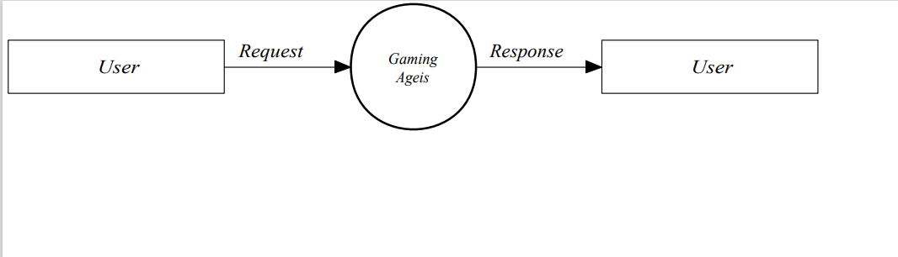

**First Level DFD**

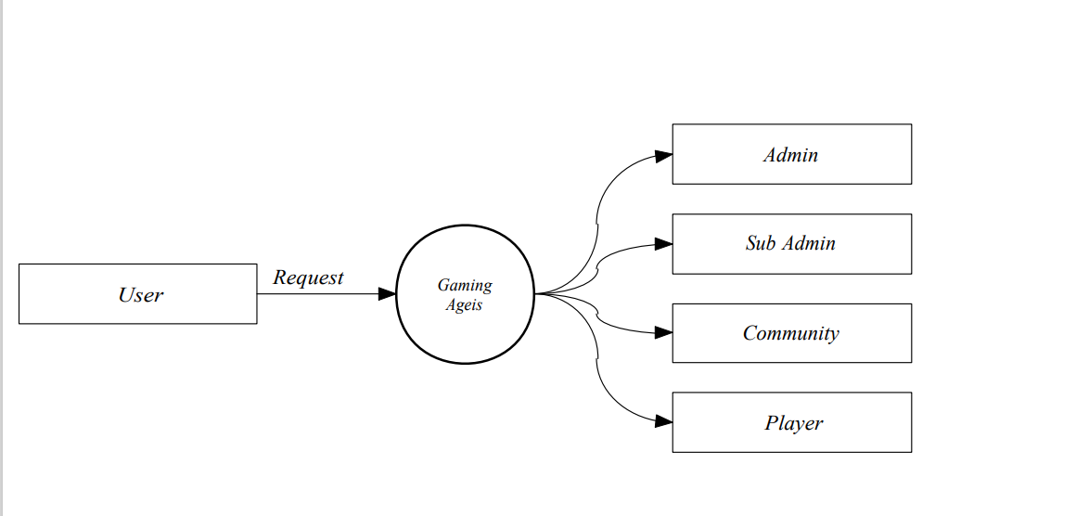

**Second Level DFD for Admin**

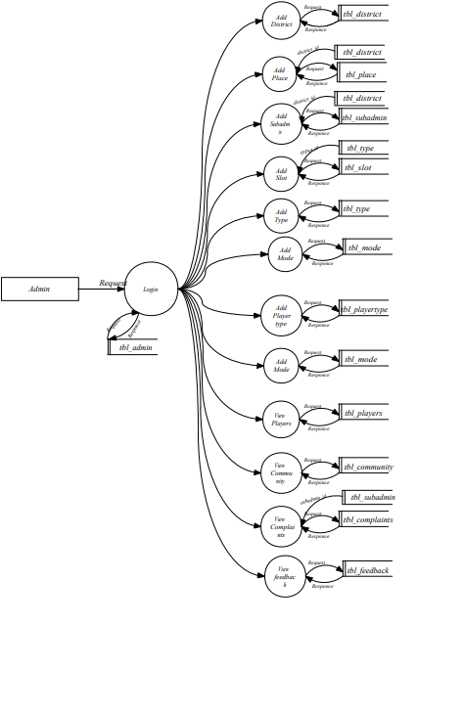

**Second Level DFD for SubAdmin**

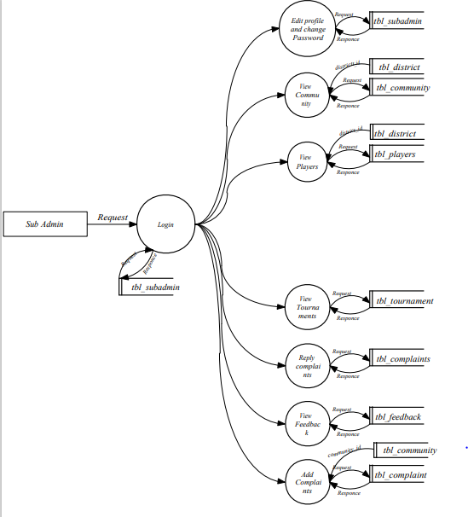

**Second Level DFD for Community**

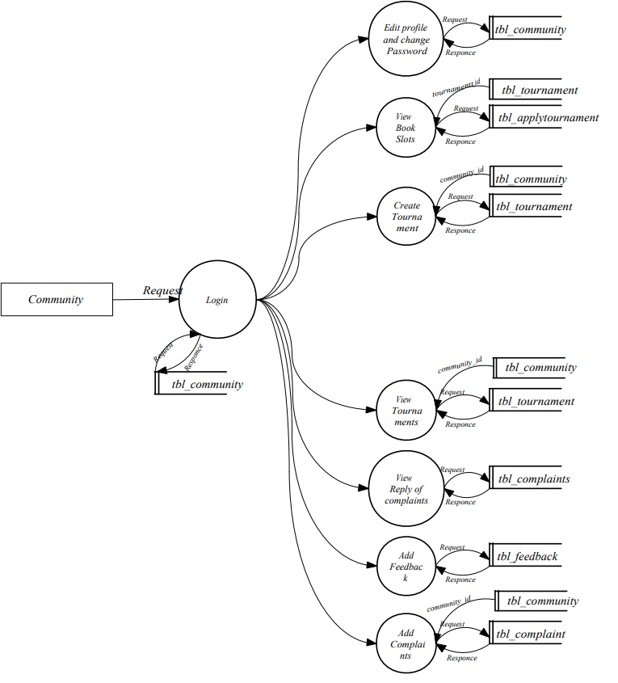

**Second Level DFD for Player**

